**Stationary Drone Jammer**

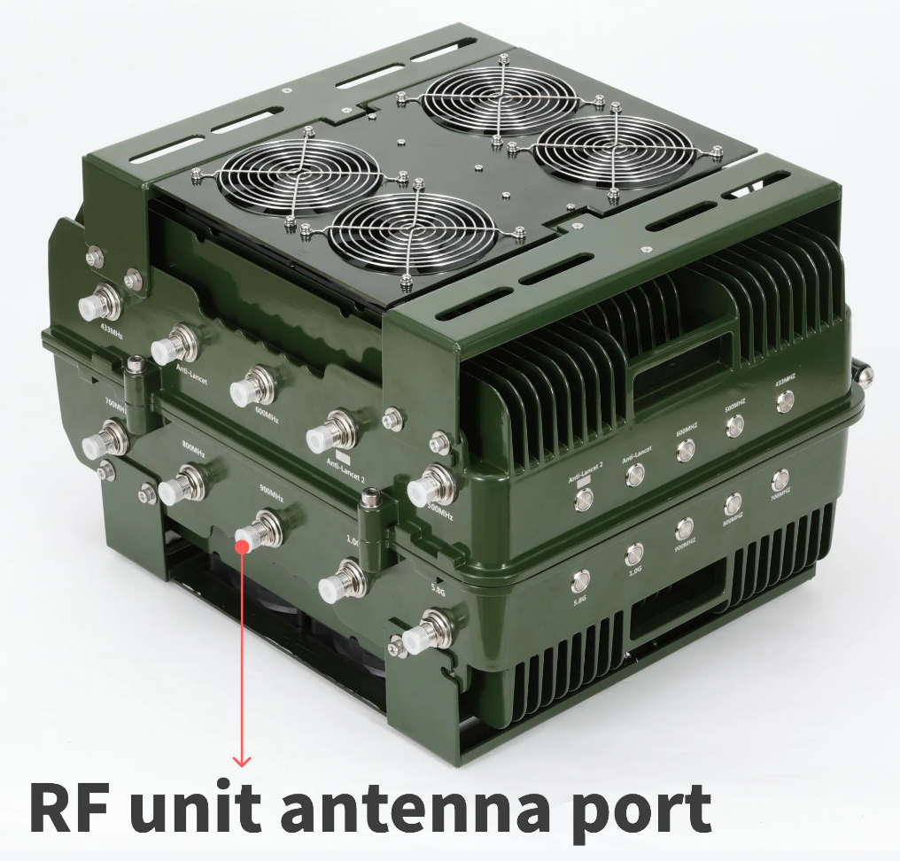

## Product Description

**8 Channels UAV Counter 700-868,868-930,930-1000,1000-1100,1200,2400,5200,5800,UAV Signal Jammer**

UAV Drone Jammer, Built-in high gain directional antenna, Built-in 8 sets of independently operated RF working unit, can choose to on/off GPS to drive the drone or force the drone to land, can be transmitted shielding interference signals to the surrounding 25-degree angle, Coverage (1000-3000m) can be comprehensive and stable uninterrupted shielding of the 433MHz 900MHz GPSL1, WIFI 2.4G, 5.8G bands in the UAV frequency band.**Applications:**

Sensitive Areas

Prisons

Oil Refineries

Military Bases

Protected Areas

**Function:**  
Effective interference with UAV Remote-Control Signal **700-868,868-930,930-1000,1000-1100,1200,2400,5200,5800**  
**Feature**

1. Higher gain antenna 17dBi

2. Strong jamming range, 1000-2000meters

3. Cooling fan design, Working 24*7 Hours

4.WaterproofIP65

5.Lightning protection

6.360°Air defense area

**Application:**  
Mainly applied to prisons, airports, scientific research centers, detention houses,  
interrogation rooms, courthouses, labor camp, all kinds of military important places, etc. that forbid aerial photography by use of UAV.

**Technical Parameters:**

|  |  |  |  |
| --- | --- | --- | --- |
| **Channel** | | **Working Frequency** | **Output Power More than** |
| CH1 | 400mhz | 400-470 MHz | 47dBm |
| CH2 | 500MHZ | 500-600MHz | 47dBm |
| CH3 | 600MHZ | 650-750MHz | 47dBm |
| CH4 | 800mhz | 800-950MHz | 47dBm |
| CH5 | 900mhz | 950-1100MHz | 47dBm |
| CH6 | 1.2Ghz | 1180-1200MHz | 47dBm |
| CH7 | 1.5GHz | 1550-1620MHz | 47dBm |
| CH8 | 2.4GHz | 2400-2500MHz | 47dBm |
| CH9 | 5.2Ghz | 5150-5300Mhz | 47dBm |
| CH10 | 5.8Ghz | 5725-5850Mhz | 47dBm |
| Power Supply | | AC110-240V | |
| Working Time | | 7*24 Hours | |
| Working Temperature | | From -20°C to 70°C | |
| Total Output Power | | 360Watts | |
| Weight | | 40Kg | |
| Size | | 800*600*260 mm | |
| Omni Antenna | | 50Watts | |

PLEASE NOTE:

1. The power supply 220V, the power button, the switches for each channel should be on the bottom of the device.
2. Complete sets with the Glass Omni antenna and power supply .